EXPERIMENT 1

**Configuration of Network Devices using Packet Tracer tools(Hub, Switch, Ethernet, Broadcast)**

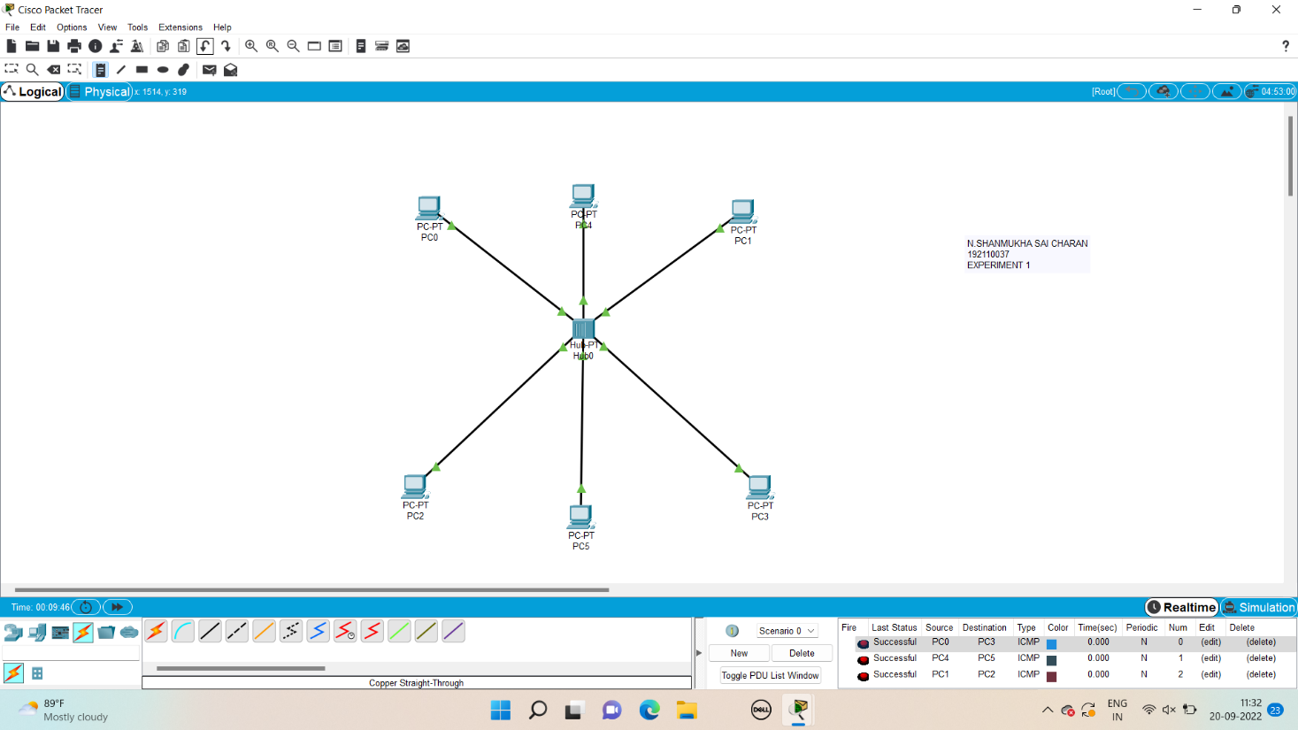EXPERIMENT 2

**Configuration of Topologies using Packet Tracer (Star, Bus, Ring)**

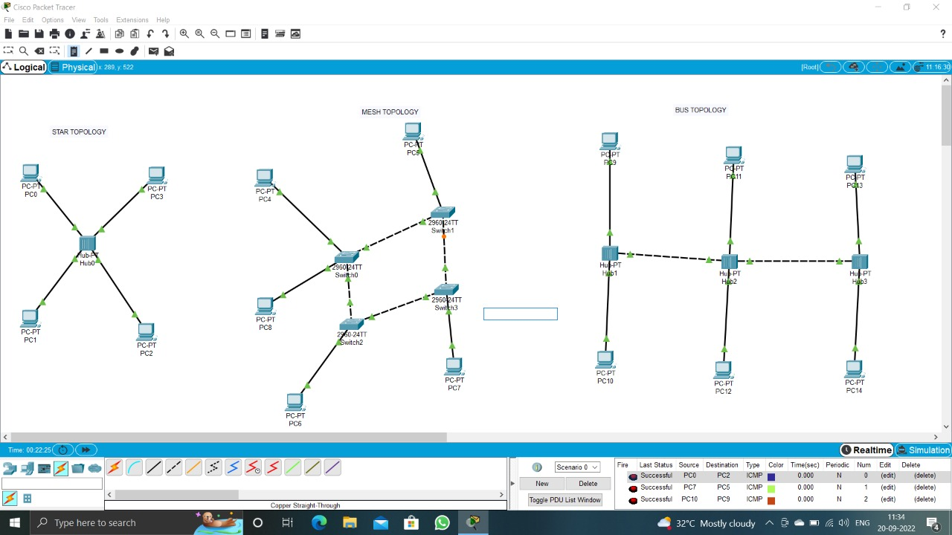

EXPERIMENT 3

**Configuration of Topologies using Packet Tracer (Mesh, Tree ,Hybrid)**

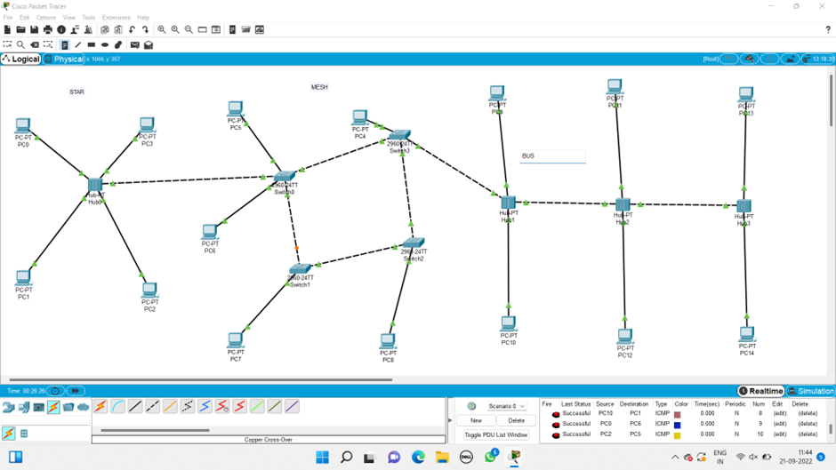

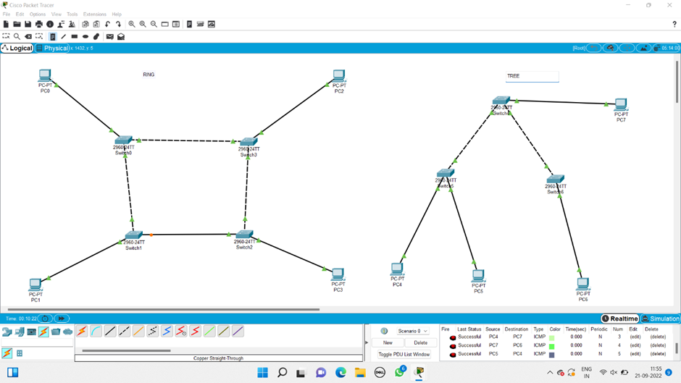

**EXPERIMRNT 4**

**Data Link Layer Traffic Simulation using Packet Tracer Analysis of ARP**

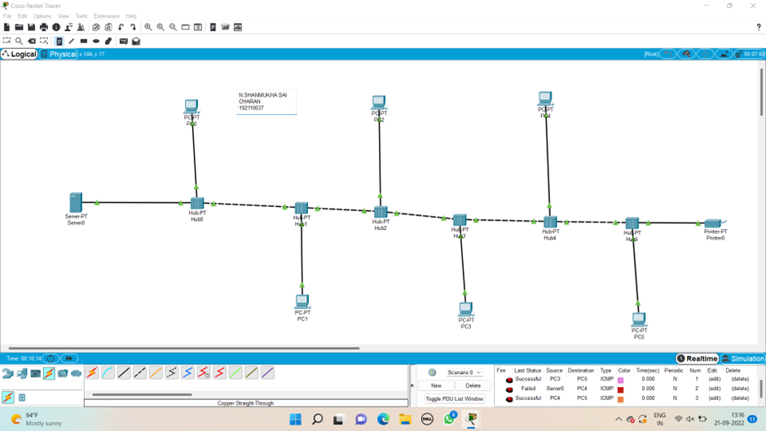

**EXPERIMENT 5**

**Data Link Layer Traffic Simulation using Packet Tracer Analysis of LLDP**

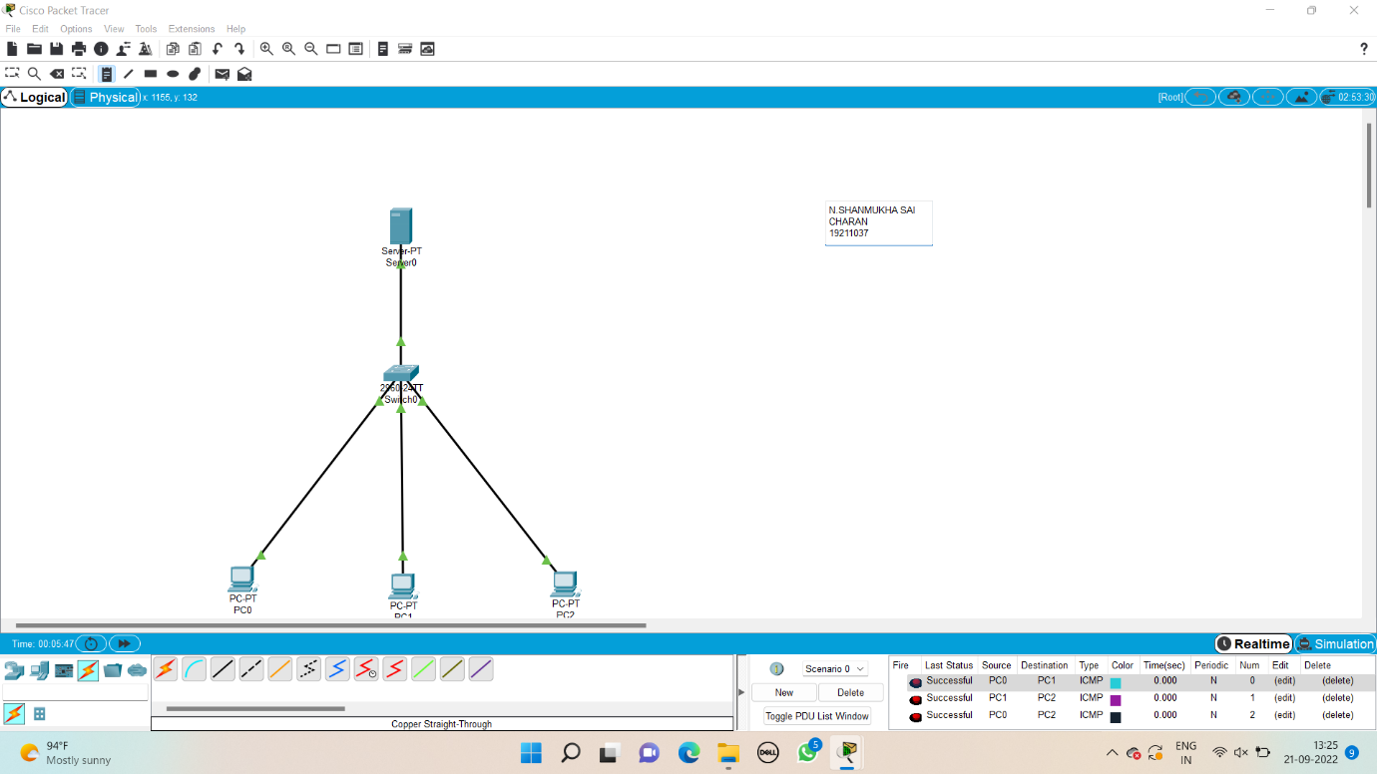

**EXPERIMRNT 6**

**Static Routing using Packet Tracer**

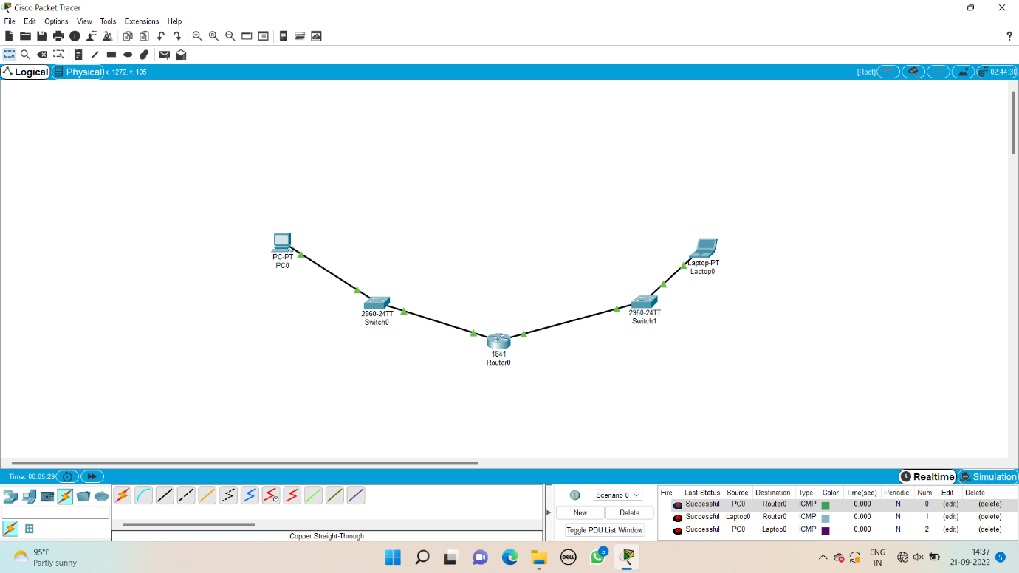

EXPERIMENT 7

**Dynamic Routing using Packet Tracer (Distance vector & OSPF)** 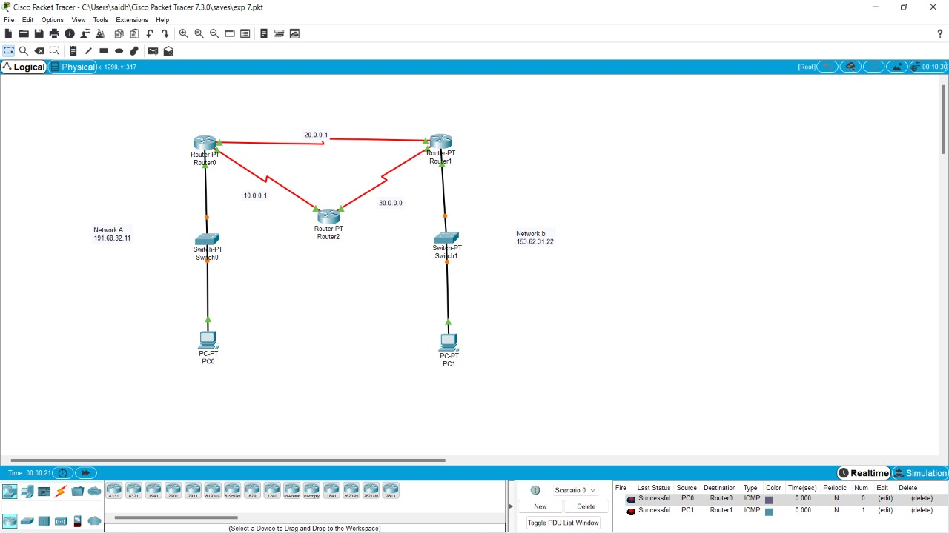

**EXPERIMENT 8**

**Subnetting -class C Addressing**

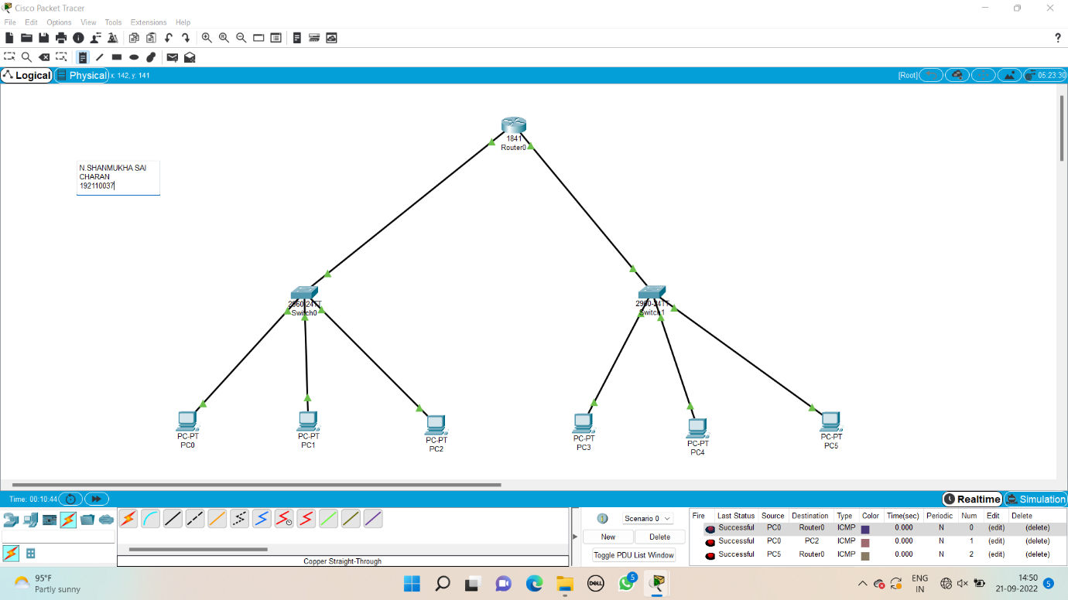

EXPERIMENT 9

**Functionalities of TCP,UDP**

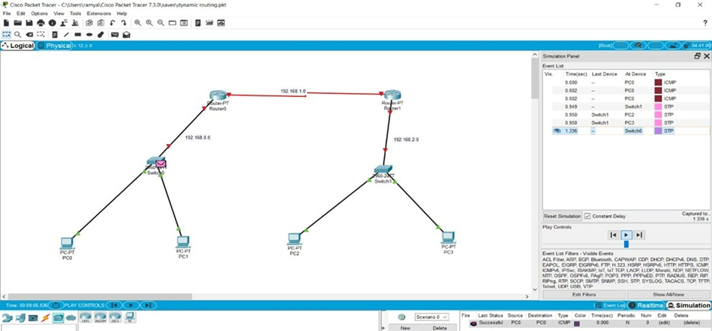

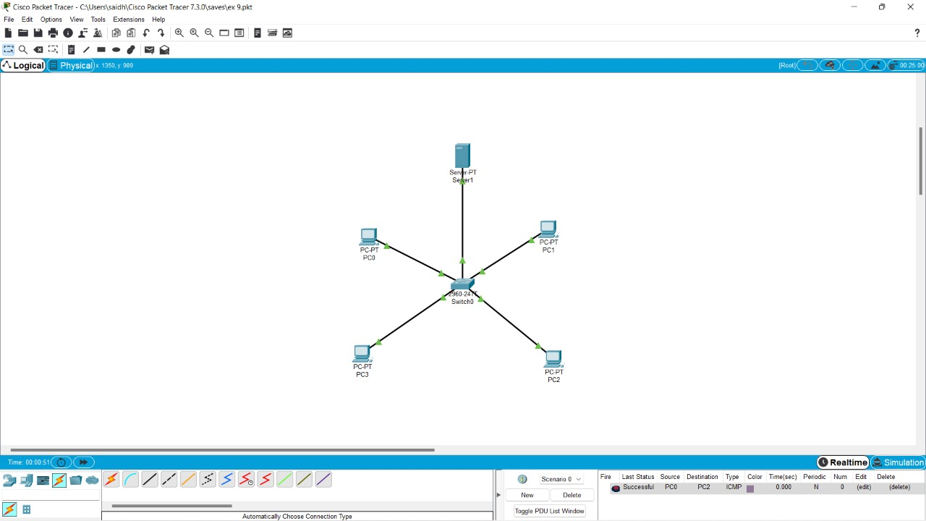

Experiment-10

TCP, UDP Exploration Solution

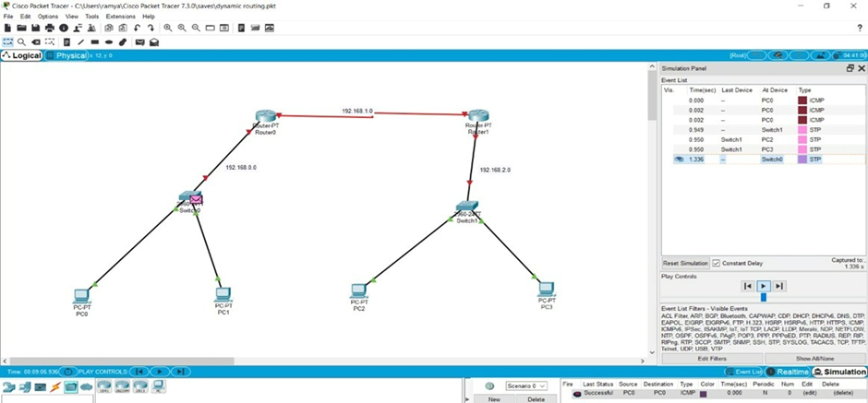



EXPERIMENT 11

IOT Based Smart Home Using Cisco Packet Tracer

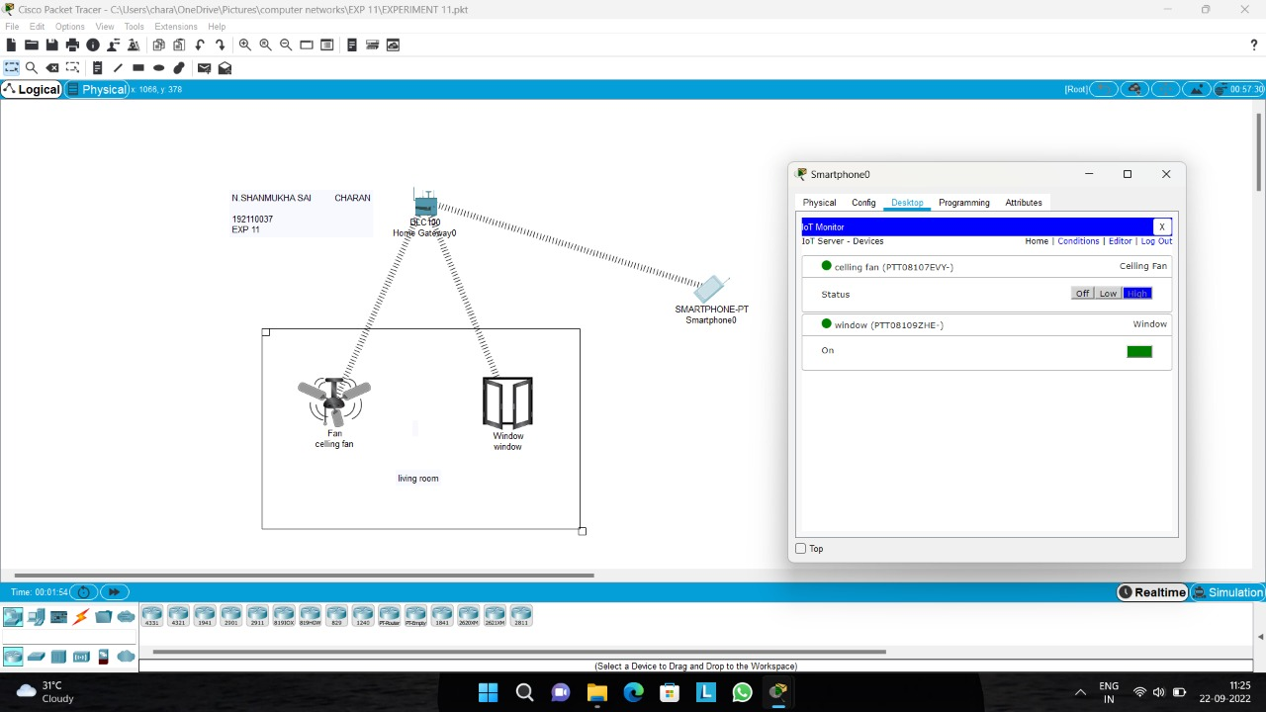

EXPERIMENT 12

Smart Garden in Cisco Packet Tracer

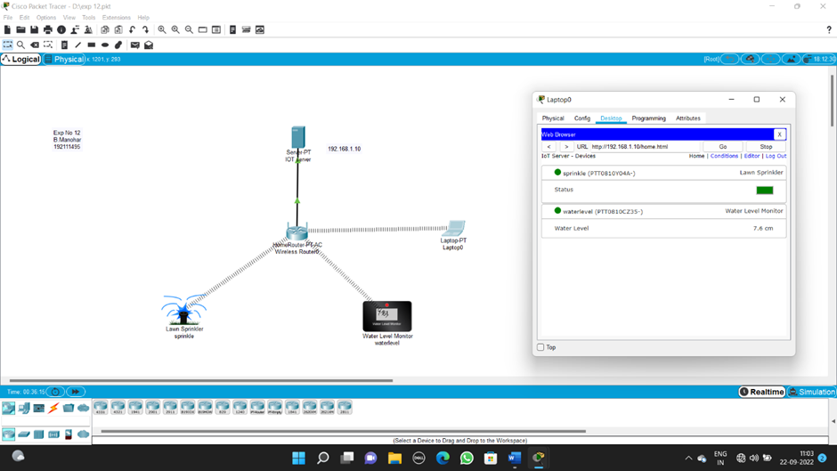

EXPERIMENT 13

IOT Devices in Networking Using Cisco Packet Tracer

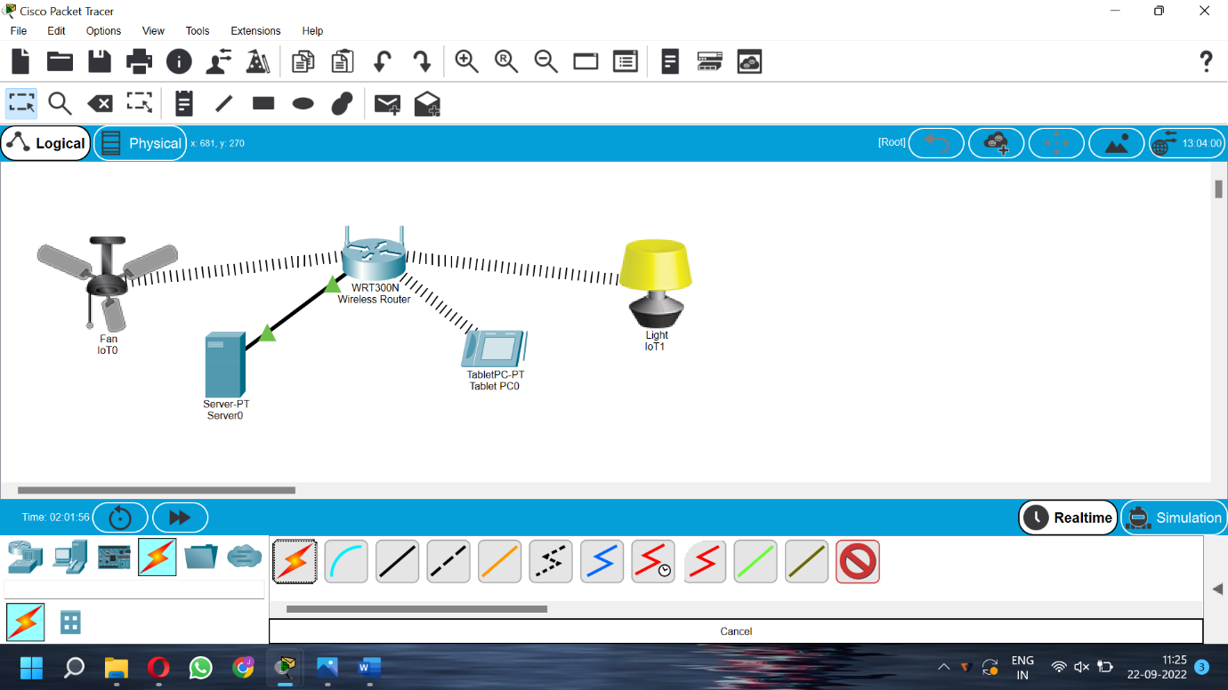

EXPERIMENT 14

Simulating X,Y,Z Company Network Design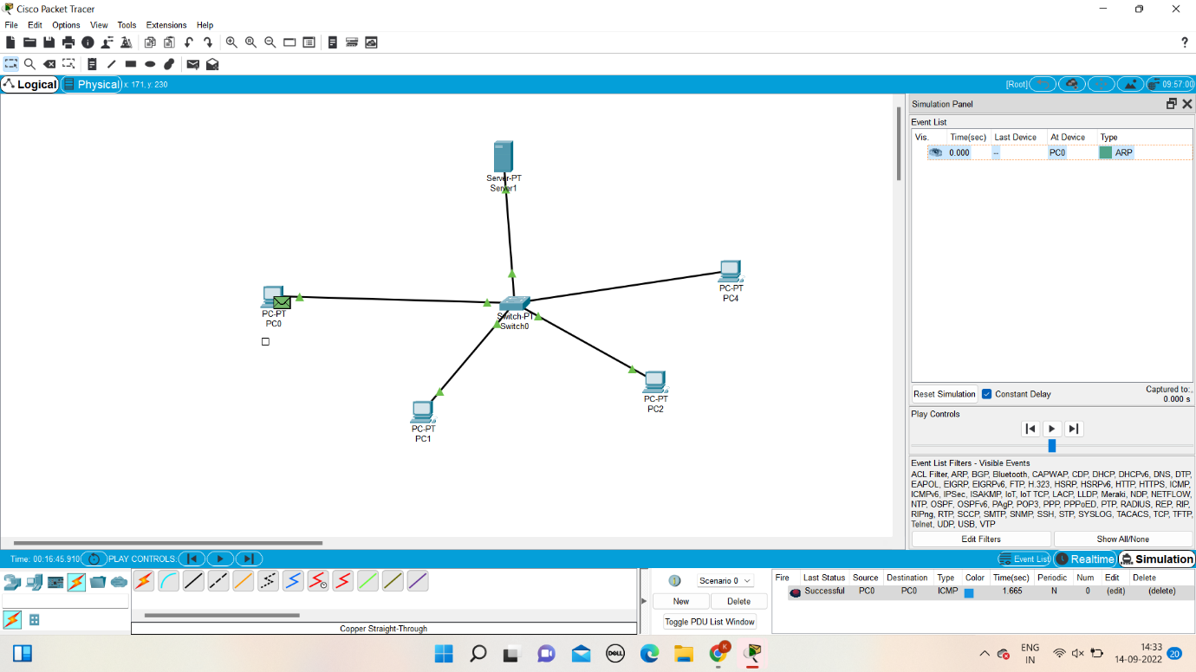

EXPERIMENT 15

Make Computer Lab in Cisco Packet Tracer

